1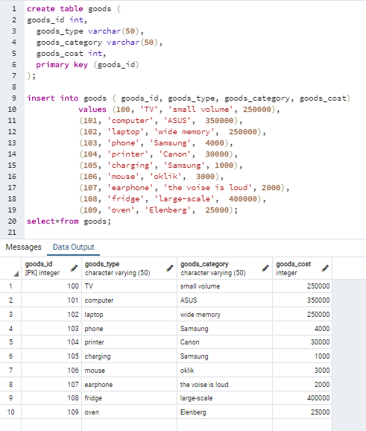

2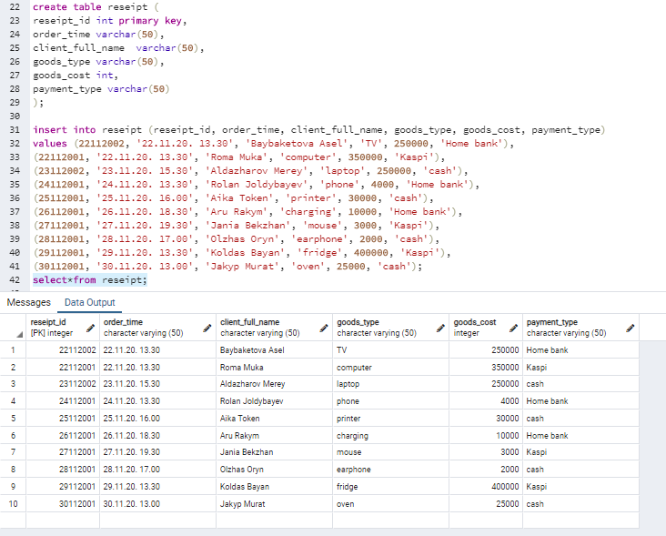

3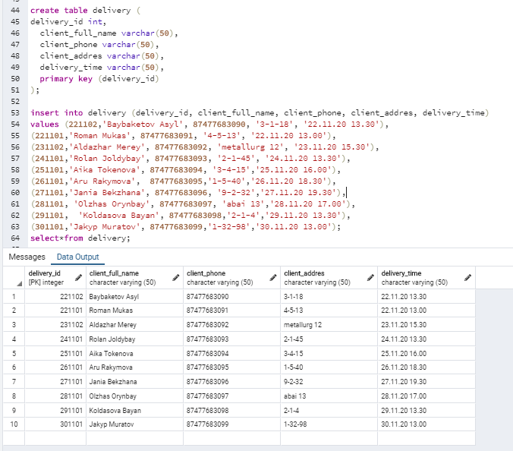

4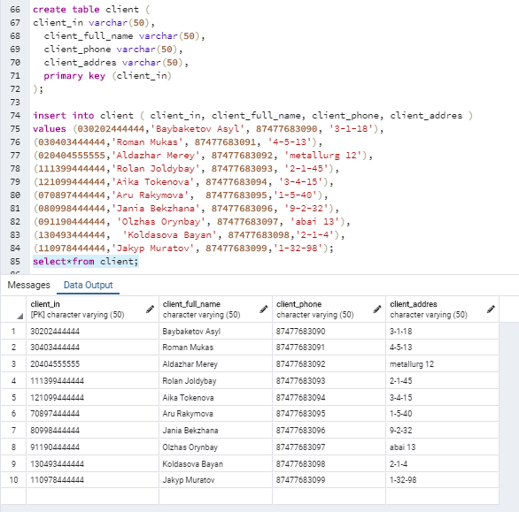

5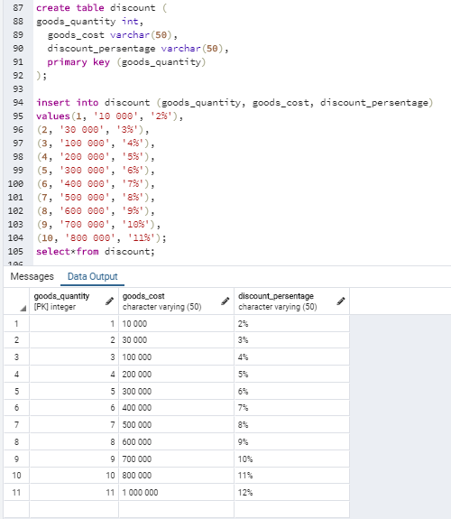

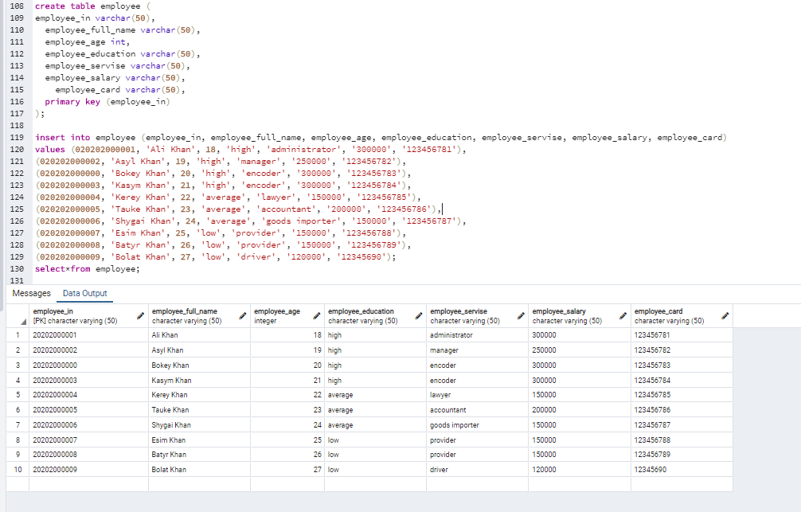

6

7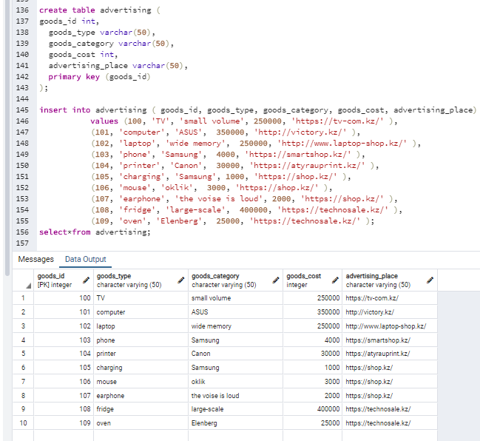

8 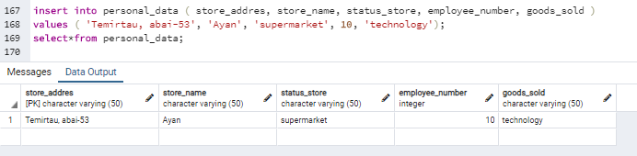

**create table goods (**

**goods_id int,**

**goods_type varchar(50),**

**goods_category varchar(50),**

**goods_cost int,**

**primary key (goods_id)**

**);**

insert into goods ( goods_id, goods_type, goods_category, goods_cost)

values (100, 'TV', 'small volume', 250000),

(101, 'computer', 'ASUS', 350000),

(102, 'laptop', 'wide memory', 250000),

(103, 'phone', 'Samsung', 4000),

(104, 'printer', 'Canon', 30000),

(105, 'charging', 'Samsung', 1000),

(106, 'mouse', 'oklik', 3000),

(107, 'earphone', 'the voise is loud', 2000),

(108, 'fridge', 'large-scale', 400000),

(109, 'oven', 'Elenberg', 25000);

select*from goods;

**create table reseipt (**

**reseipt_id int primary key,**

**order_time varchar(50),**

**client_full_name varchar(50),**

**goods_type varchar(50),**

**goods_cost int,**

**payment_type varchar(50)**

**);**

insert into reseipt (reseipt_id, order_time, client_full_name, goods_type, goods_cost, payment_type)

values (22112002, '22.11.20. 13.30', 'Baybaketova Asel', 'TV', 250000, 'Home bank'),

(22112001, '22.11.20. 13.30', 'Roma Muka', 'computer', 350000, 'Kaspi'),

(23112002, '23.11.20. 15.30', 'Aldazharov Merey', 'laptop', 250000, 'cash'),

(24112001, '24.11.20. 13.30', 'Rolan Joldybayev', 'phone', 4000, 'Home bank'),

(25112001, '25.11.20. 16.00', 'Aika Token', 'printer', 30000, 'cash'),

(26112001, '26.11.20. 18.30', 'Aru Rakym', 'charging', 10000, 'Home bank'),

(27112001, '27.11.20. 19.30', 'Jania Bekzhan', 'mouse', 3000, 'Kaspi'),

(28112001, '28.11.20. 17.00', 'Olzhas Oryn', 'earphone', 2000, 'cash'),

(29112001, '29.11.20. 13.30', 'Koldas Bayan', 'fridge', 400000, 'Kaspi'),

(30112001, '30.11.20. 13.00', 'Jakyp Murat', 'oven', 25000, 'cash');

select*from reseipt;

**create table delivery (**

**delivery_id int,**

**client_full_name varchar(50),**

**client_phone varchar(50),**

**client_addres varchar(50),**

**delivery_time varchar(50),**

**primary key (delivery_id)**

**);**

insert into delivery (delivery_id, client_full_name, client_phone, client_addres, delivery_time)

values (221102,'Baybaketov Asyl', 87477683090, '3-1-18', '22.11.20 13.30'),

(221101,'Roman Mukas', 87477683091, '4-5-13', '22.11.20 13.00'),

(231102,'Aldazhar Merey', 87477683092, 'metallurg 12', '23.11.20 15.30'),

(241101,'Rolan Joldybay', 87477683093, '2-1-45', '24.11.20 13.30'),

(251101,'Aika Tokenova', 87477683094, '3-4-15','25.11.20 16.00'),

(261101,'Aru Rakymova', 87477683095,'1-5-40','26.11.20 18.30'),

(271101,'Jania Bekzhana', 87477683096, '9-2-32','27.11.20 19.30'),

(281101, 'Olzhas Orynbay', 87477683097, 'abai 13','28.11.20 17.00'),

(291101, 'Koldasova Bayan', 87477683098,'2-1-4','29.11.20 13.30'),

(301101,'Jakyp Muratov', 87477683099,'1-32-98','30.11.20 13.00');

select*from delivery;

**create table client (**

**client_in varchar(50),**

**client_full_name varchar(50),**

**client_phone varchar(50),**

**client_addres varchar(50),**

**primary key (client_in)**

**);**

insert into client ( client_in, client_full_name, client_phone, client_addres )

values (030202444444,'Baybaketov Asyl', 87477683090, '3-1-18'),

(030403444444,'Roman Mukas', 87477683091, '4-5-13'),

(020404555555,'Aldazhar Merey', 87477683092, 'metallurg 12'),

(111399444444,'Rolan Joldybay', 87477683093, '2-1-45'),

(121099444444,'Aika Tokenova', 87477683094, '3-4-15'),

(070897444444,'Aru Rakymova', 87477683095,'1-5-40'),

(080998444444,'Jania Bekzhana', 87477683096, '9-2-32'),

(091190444444, 'Olzhas Orynbay', 87477683097, 'abai 13'),

(130493444444, 'Koldasova Bayan', 87477683098,'2-1-4'),

(110978444444,'Jakyp Muratov', 87477683099,'1-32-98');

select*from client;

**create table discount (**

**goods_quantity int,**

**goods_cost varchar(50),**

**discount_persentage varchar(50),**

**primary key (goods_quantity)**

**);**

insert into discount (goods_quantity, goods_cost, discount_persentage)

values(1, '10 000', '2%'),

(2, '30 000', '3%'),

(3, '100 000', '4%'),

(4, '200 000', '5%'),

(5, '300 000', '6%'),

(6, '400 000', '7%'),

(7, '500 000', '8%'),

(8, '600 000', '9%'),

(9, '700 000', '10%'),

(10, '800 000', '11%');

select*from discount;

**create table employee (**

**employee_in varchar(50),**

**employee_full_name varchar(50),**

**employee_age int,**

**employee_education varchar(50),**

**employee_servise varchar(50),**

**employee_salary varchar(50),**

**employee_card varchar(50),**

**primary key (employee_in)**

**);**

insert into employee (employee_in, employee_full_name, employee_age, employee_education, employee_servise, employee_salary, employee_card)

values (020202000001, 'Ali Khan', 18, 'high', 'administrator', '300000', '123456781'),

(020202000002, 'Asyl Khan', 19, 'high', 'manager', '250000', '123456782'),

(020202000000, 'Bokey Khan', 20, 'high', 'encoder', '300000', '123456783'),

(020202000003, 'Kasym Khan', 21, 'high', 'encoder', '300000', '123456784'),

(020202000004, 'Kerey Khan', 22, 'average', 'lawyer', '150000', '123456785'),

(020202000005, 'Tauke Khan', 23, 'average', 'accountant', '200000', '123456786'),

(020202000006, 'Shygai Khan', 24, 'average', 'goods importer', '150000', '123456787'),

(020202000007, 'Esim Khan', 25, 'low', 'provider', '150000', '123456788'),

(020202000008, 'Batyr Khan', 26, 'low', 'provider', '150000', '123456789'),

(020202000009, 'Bolat Khan', 27, 'low', 'driver', '120000', '12345690');

select*from employee;

**create table advertising (**

**goods_id int,**

**goods_type varchar(50),**

**goods_category varchar(50),**

**goods_cost int,**

**advertising_place varchar(50),**

**primary key (goods_id)**

**);**

insert into advertising ( goods_id, goods_type, goods_category, goods_cost, advertising_place)

values (100, 'TV', 'small volume', 250000, 'https://tv-com.kz/' ),

(101, 'computer', 'ASUS', 350000, 'http://victory.kz/' ),

(102, 'laptop', 'wide memory', 250000, 'http://www.laptop-shop.kz/' ),

(103, 'phone', 'Samsung', 4000, 'https://smartshop.kz/' ),

(104, 'printer', 'Canon', 30000, 'https://atyrauprint.kz/' ),

(105, 'charging', 'Samsung', 1000, 'https://shop.kz/' ),

(106, 'mouse', 'oklik', 3000, 'https://shop.kz/' ),

(107, 'earphone', 'the voise is loud', 2000, 'https://shop.kz/' ),

(108, 'fridge', 'large-scale', 400000, 'https://technosale.kz/' ),

(109, 'oven', 'Elenberg', 25000, 'https://technosale.kz/' );

select*from advertising;

**create table personal_data (**

**store_addres varchar(50),**

**store_name varchar(50),**

**status_store varchar(50),**

**employee_number int,**

**goods_sold varchar(50),**

**primary key (store_addres)**

**);**

insert into personal_data ( store_addres, store_name, status_store, employee_number, goods_sold )

values ( 'Temirtau, abai-53', 'Ayan', 'supermarket', 10, 'technology');

select*from personal_data;